1. Facial recognition using Principal Component Analysis (PCA) and Normalized Principal Component Analysis (N- PCA).

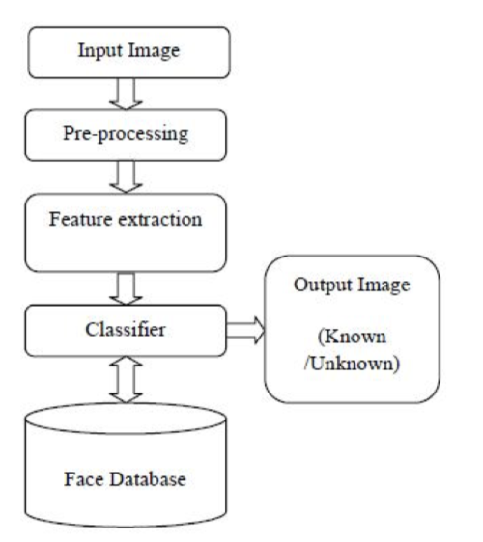

The outline of typical face recognition system implemented specifically for N-PCA is given in right figure. After the pre-processing the normalized face image is given as input to the feature extraction module to find the key features that will be used for classification. The module composes a feature vector that is well enough to represent the face image. It is used to match the test image with the train images stored in a database. If the face is recognized as unknown, face images can then be added to the database for further comparisons.

Eigen Values and Eigen Vectors

Some key points about facial recognition

1. Eigen value (λ) associated with the eigenvector (X). Eigen vector is a vector that is scaled by linear transformation. It is a property of matrix. When a matrix acts on it, only the vector magnitude is changed not the direction.In my opinion, Eigen vector is a key points from an image that can represent this image with orientation invariant.
2. Face Image Representation ->Mean Centered Images by each subject ->Covariance Matrix (Eigen vectors corresponding to AAT can now be easily calculated with reduced dimensionality where AXi is the Eigen vector and λi is the Eigen value. )->Eigen face space()->recognition
3. The Eigen vectors of the covariance matrix AAT are AX i which is denoted by U i Eigen vectors correspond to each Eigen face in the face space and discard the faces for which Eigen values are zero thus reducing the Eigen face space to an extent. The Eigen faces are ranked according to their usefulness in characterizing the variation among the images.
4. The face recognition system consists of two important steps, the feature extraction and the classification.
5. The accuracy of face recognition algorithm was measured by Euclidian distance between the test face and all train faces.

N-PCA

Collection of Images to make the Database ->Checking whether Image is colored or gray (if color covert into gray)-> Mean and Standard Deviation of Image ->Normalization ->Calculating Train Centred Images->Calculating Eigen Vectors and Values-> Creating Eigen faces ->Calculating Train Weights->Store Train Weights in Sink for Further Comparison ->Euclidean distance Classifier ->Face Recognized